**5. Hardware designing**

**Components description**

1. **Arduino uno R3**

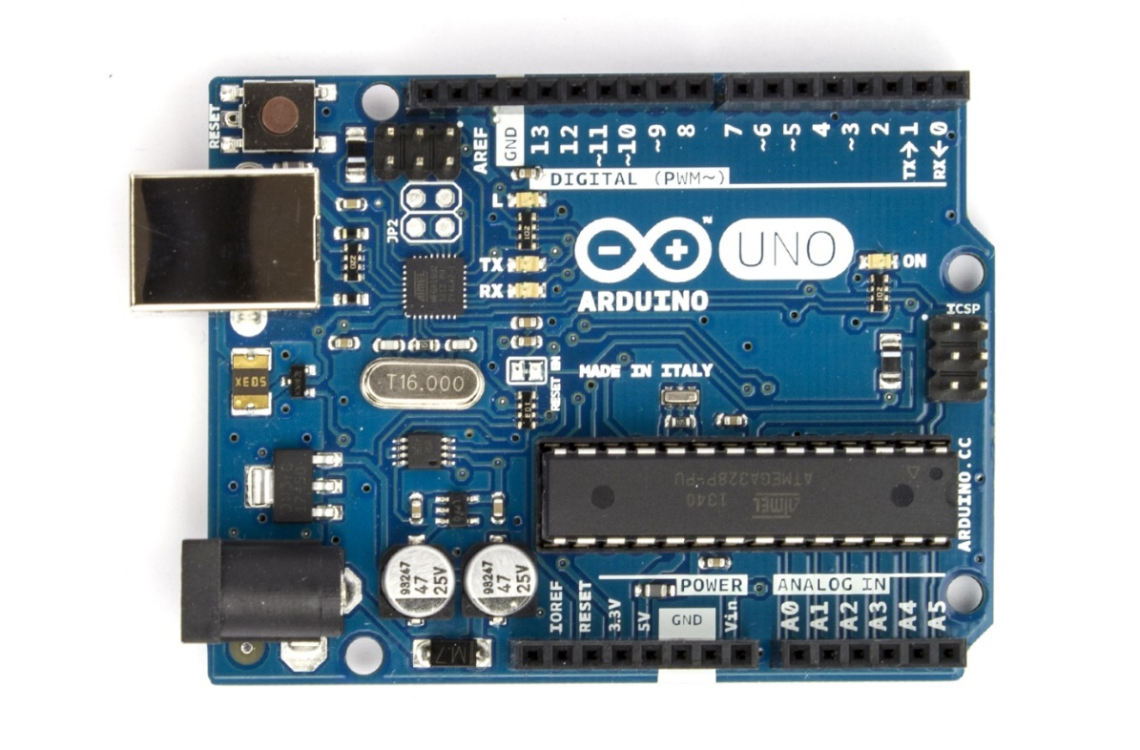

**Overview**

The Arduino Uno is a microcontroller board based on the ATmega328 (datasheet). It has 14 digital input/output pins (of which 6 can be used as PWM outputs), 6 analog inputs, a 16 MHz ceramic resonator, a USB connection, a power jack, an ICSP header, and a reset button. It contains everything needed to support the microcontroller; simply connect it to a computer with a USB cable or power it with a AC-to-DC adapter or battery to get started. The Uno differs from all preceding boards in that it does not use the FTDI USB-to-serial driver chip. Instead, it features the Atmega16U2 (Atmega8U2 up to version R2) programmed as a USB-to-serial converter.

**Revision 2** of the Uno board has a resistor pulling the 8U2 HWB line to ground, making it easier to put into DFU mode.

**Revision 3** of the board has the following new features:

* pinout: added SDA and SCL pins that are near to the AREF pin and two other new pins placed near to the RESET pin, the IOREF that allow the shields to adapt to the voltage provided from the board. In future, shields will be compatible both with the board that use the AVR, which operate with 5V and with the Arduino Due that operate with 3.3V. The second one is a not connected pin, that is reserved for future purposes.
* Stronger RESET circuit.
* Atmega 16U2 replace the 8U2.

"Uno" means one in Italian and is named to mark the upcoming release of Arduino 1.0. The Uno and version 1.0 will be the reference versions of Arduino, moving forward. The Uno is the latest in a series of USB Arduino boards, and the reference model for the Arduino platform; for a comparison with previous versions, see the index of Arduino boards.

**Features of Arduino uno**

* Microcontroller ATmega328
* Operating Voltage 5V
* Input Voltage (recommended) 7-12V
* Input Voltage (limits) 6-20V
* Digital I/O Pins 14 (of which 6 provide PWM output)
* Analog Input Pins 6
* DC Current per I/O Pin 40 mA
* DC Current for 3.3V Pin 50 mA
* Flash Memory 32 KB (ATmega328) of which 0.5 KB used by bootloader
* SRAM 2 KB (ATmega328)
* EEPROM 1 KB (ATmega328)
* Clock Speed 16 MHz

**Arduino Uno R3 Pin Diagram**

The Arduino Uno R3 pin diagram is shown below. It comprises 14-digit I/O pins. From these pins, 6-pins can be utilized like PWM outputs. This board includes 14 digital input/output pins, Analog inputs-6, a USB connection, quartz crystal-16 MHz, a power jack, a [USB connection](https://www.elprocus.com/can-interface-to-usb/), resonator-16Mhz, a power jack, an ICSP header an RST button.

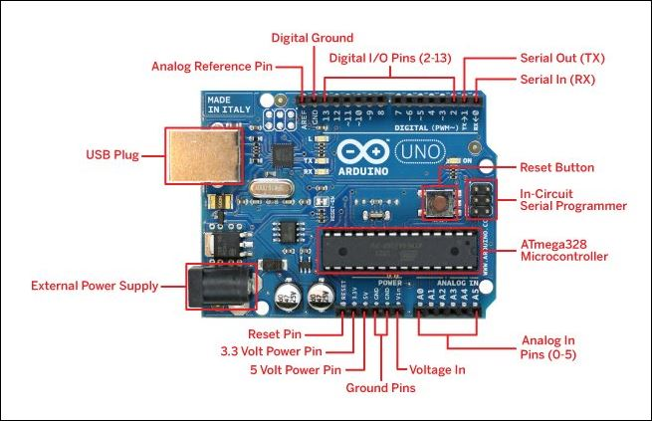

**Power Supply**

The [power supply](https://www.elprocus.com/difference-between-single-phase-and-three-phase-ac-power-supply/) of the Arduino can be done with the help of an exterior power supply otherwise USB connection. The exterior power supply (6 to 20 volts) mainly includes a battery or an AC to DC adapter. The connection of an adapter can be done by plugging a center-positive plug (2.1mm) into the power jack on the board. The battery terminals can be placed in the pins of Vin as well as GND. The power pins of an **Arduino board** include the following.

**Vin:** The input voltage or Vin to the Arduino while it is using an exterior power supply opposite to volts from the connection of USB or else [**RPS (regulated power supply)**](https://www.elprocus.com/classification-power-supply-different-types/). By using this pin, one can supply the voltage.

**5Volts:** The RPS can be used to give the power supply to [the microcontroller](https://www.elprocus.com/arm7-based-lpc2148-microcontroller-pin-configuration/) as well as components which are used on the Arduino board. This can approach from the input voltage through a regulator.

**3V3:** A 3.3 supply voltage can be generated with the onboard regulator, and the highest draw current will be 50 mA.

**GND:** GND (ground) pins

**Memory**

The memory of an ATmega328 microcontroller includes 32 KB and 0.5 KB memory is utilized for the Boot loader), and also it includes SRAM-2 KB as well as EEPROM-1KB.

**Input and Output**

We know that an arguing Uno R3 includes 14-digital pins which can be used as an input otherwise output by using the functions like pin Mode (), digital Read(), and digital Write(). These pins can operate with 5V, and every digital pin can give or receive 20mA, & includes a 20k to 50k ohm [pull up resistor](https://www.elprocus.com/pull-up-and-pull-down-resistors-with-applications/). The maximum current on any pin is 40mA which cannot surpass for avoiding the microcontroller from the damage. Additionally, some of the pins of an Arduino include specific functions.

**Serial Pins**

The serial pins of an Arduino board are TX (1) and RX (0) pins and these pins can be used to transfer the TTL serial data. The connection of these pins can be done with the equivalent pins of the ATmega8 U2 USB to TTL chip.

**External Interrupt Pins**

The external interrupt pins of the board are 2 & 3, and these pins can be arranged to activate an interrupt on a rising otherwise falling edge, a low-value otherwise a modify in value

**PWM Pins**

The PWM pins of an Arduino are 3, 5, 6, 9, 10, & 11, and gives an output of an 8-bit PWM with the function analog Write ().

**SPI (Serial Peripheral Interface) Pins**

The SPI pins are 10, 11, 12, 13 namely SS, MOSI, MISO, SCK, and these will maintain the [**SPI communication**](https://www.elprocus.com/serial-peripheral-interface-spi-communication-protocol/) with the help of the SPI library.

**LED Pin**

An arguing board is inbuilt with [a LED](https://www.elprocus.com/bipolar-led-driver-circuit-working-application/) using digital pin-13. Whenever the digital pin is high, the LED will glow otherwise it will not glow.

**TWI (2-Wire Interface) Pins**

The TWI pins are SDA or A4, & SCL or A5, which can support the communication of TWI with the help of Wire library.

**AREF (Analog Reference) Pin**

An analog reference pin is the reference voltage to the inputs of an analog i/ps using the function like analog Reference().

**Reset (RST) Pin**

This pin brings a low line for resetting the microcontroller, and it is very useful for using an RST button toward shields which can block the one over the Arduino R3 board.

**Communication**

The communication protocols of an Arduino Uno include SPI, I2C, and [**UART serial communication**](https://www.elprocus.com/basics-of-uart-communication-block-diagram-applications/).

**UART**

An Arduino Uno uses the two functions like the transmitter digital pin1 and the receiver digital pin0. These pins are mainly used in UART [TTL](https://www.elprocus.com/transistor-transistor-logic-ttl/) serial communication.

**I2C**

An Arduino UNO board employs SDA pin otherwise A4 pin & A5 pin otherwise SCL pin is used for [I2C communication](https://www.elprocus.com/i2c-bus-protocol-tutorial-interface-applications/) with wire library. In this, both the SCL and SDA are CLK signal and data signal.

**SPI Pins**

The SPI communication includes MOSI, MISO, and SCK.

**MOSI (Pin11)**

This is the master out slave in the pin, used to transmit the data to the devices

**MISO (Pin12)**

This pin is a serial CLK, and the CLK pulse will synchronize the transmission of which is produced by the master.

**SCK (Pin13)**

The CLK pulse synchronizes data transmission that is generated by the master. Equivalent pins with the SPI library is employed for the communication of SPI. ICSP (in-circuit serial programming) headers can be utilized for programming **[ATmega microcontroller](https://www.elprocus.com/avr-atmega8-microcontroller-architecture-applications/" \t "_blank)** directly with the boot loader.

### Arduino Uno R3 Programming

* The programming of an Arduino Uno R3 can be done using IDE software. The microcontroller on the board will come with pre-burned by a boot loader that permits to upload fresh code without using an exterior hardware programmer.
* The communication of this can be done using a protocol like STK500.
* We can also upload the program in the microcontroller by avoiding the boot loader using the header like the In-Circuit Serial Programming.

**Automatic (Software) Reset**

Rather than requiring a physical press of the reset button before an upload, the Arduino Uno is designed in a way that allows it to be reset by software running on a connected computer. One of the hardware flow control lines (DTR) of the ATmega8U2/16U2 is connected to the reset line of the ATmega328 via a 100 nanofarad capacitor. When this line is asserted (taken low), the reset line drops long enough to reset the chip. The Arduino software uses this capability to allow you to upload code by simply pressing the upload button in the Arduino environment. This means that the bootloader can have a shorter timeout, as the lowering of DTR can be well-coordinated with the start of the upload. This setup has other implications. When the Uno is connected to either a computer running Mac OS X or Linux, it resets each time a connection is made to it from software (via USB). For the following halfsecond or so, the bootloader is running on the Uno. While it is programmed to ignore malformed data (i.e. anything besides an upload of new code), it will intercept the first few bytes of data sent to the board after a connection is opened. If a sketch running on the board receives one-time configuration or other data when it first starts, make sure that the software with which it communicates waits a second after opening the connection and before sending this data. The Uno contains a trace that can be cut to disable the auto-reset. The pads on either side of the trace can be soldered together to re-enable it. It's labeled "RESET-EN". You may also be able to disable the auto-reset by connecting a 110 ohm resistor from 5V to the reset line; see this forum thread for details.

**USB Overcurrent Protection**

The Arduino Uno has a resettable polyfuse that protects your computer's USB ports from shorts and overcurrent. Although most computers provide their own internal protection, the fuse provides an extra layer of protection. If more than 500 mA is applied to the USB port, the fuse will automatically break the connection until the short or overload is removed.

**Physical Characteristics**

The maximum length and width of the Uno PCB are 2.7 and 2.1 inches respectively, with the USB connector and power jack extending beyond the former dimension. Four screw holes allow the board to be attached to a surface or case. Note that the distance between digital pins 7 and 8 is 160 mil (0.16"), not an even multiple of the 100 mil spacing of the other pins.

1. **PH SENSOR SKU SEN0161**

## **Introduction**

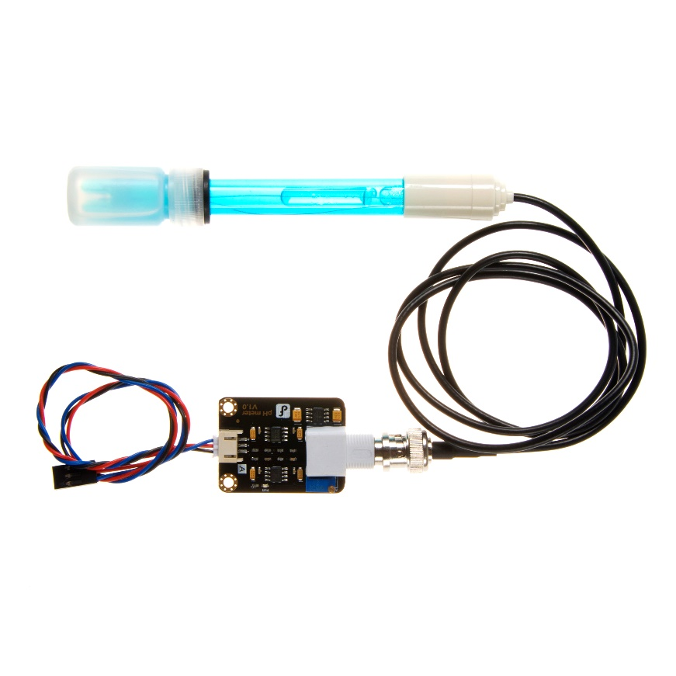

Need to measure water quality and other parameters but haven't got any low cost pH meter? Find it difficult to use with [Arduino](https://www.dfrobot.com/category-35.html)? Here comes an analog pH meter, specially designed for [**Arduino controllers**](https://www.dfrobot.com/category-104.html) and has built-in simple, convenient and practical connection and features. It has an LED which works as the Power Indicator, a BNC connector and PH2.0 sensor interface. To use it, just connect the pH sensor with BNC connector, and plug the PH2.0 interface into the analog input port of any [Arduino controller](https://www.dfrobot.com/category-104.html). If pre-programmed, you will get the pH value easily. Comes in compact plastic box with foams for better mobile storage. **Attention:In order to ensure the accuracy of the pH probe, you need to use the standard solution to calibrate it regularly.Generally, the period is about half a year. If you meaure the dirty aqueous solution, you need to increase the frequency of calibration.**

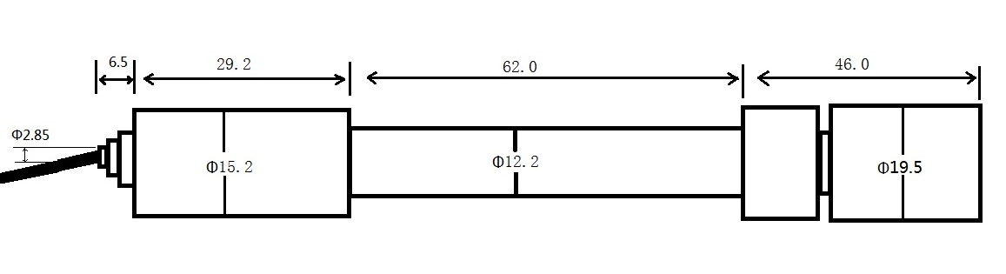**fig. pH Electrode Size**

## **Specification**

* Module Power : 5.00V
* Module Size : 43mm×32mm
* Measuring Range:0-14PH
* Measuring Temperature :0-60 ℃
* Accuracy : ± 0.1pH (25 ℃)
* Response Time : ≤ 1min
* pH Sensor with BNC Connector
* PH2.0 Interface ( 3 foot patch )
* Gain Adjustment Potentiometer
* Power Indicator LED
* Cable Length from sensor to BNC connector:660mm

1. **Temperature sensor DS18B20**

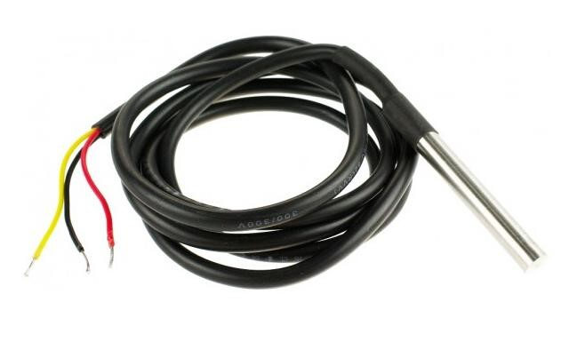

**Fig . DS18B20 Waterproof Temperature Sensor Cable**

# **Description**

This Maxim-made item is a digital thermo probe or sensor that employs DALLAS DS18B20. Its unique 1-wire interface makes it easy to communicate with devices. It can converts temperature to a 12-bit digital word in 750ms (max). Besides, it can measures temperatures from -55°C to +125°C (-67F to +257F). In addition, this thermo probe doesn't require any external power supply since it draws power from data line. Last but not least, like other common thermo probe, its stainless steel probe head makes it suitable for any wet or harsh environment.

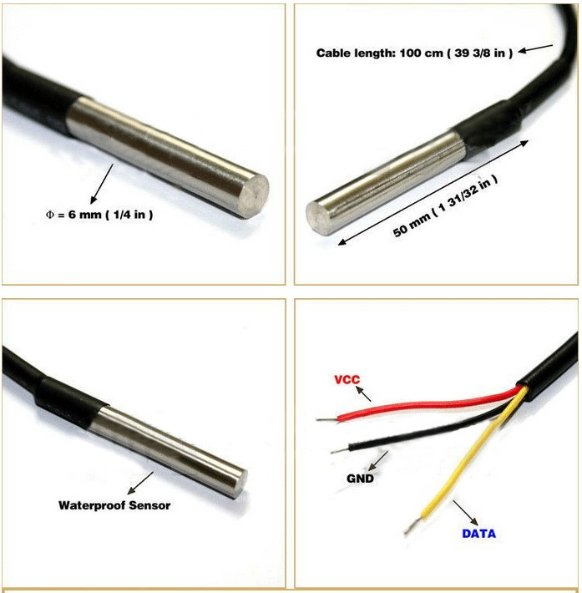

**Feature:**

* Usable temperature range: -55 to 125°C
* 9 to 12 bit selectable resolution
* Uses 1Wire interface requires only one digital pin for communication
* Unique 64 bit ID burned into chip
* Multiple sensors can share one pin
* ±0.5°C Accuracy from -10°C to +85°C
* Temperature limit alarm system
* Query time is less than 750ms
* Usable with 3.0V to 5.5V power/data
* Stainless steel tube 6mm diameter by 30mm long
* Cable is 36" long and 4mm diameter
* Contains DS18B20 temperature sensor
* Sensor has three wires - Red connects to 3-5V, Blue/Black connects to ground and Yellow/White is data .

**DS18B20 Sensor Pinout**

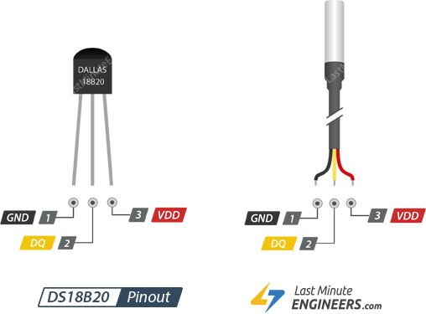

GND is a ground pin.

DQ is 1-Wire Data Bus should be connected to a digital pin on microcontroller.

VDD pin supplies power for the sensor which can be between 3.3 to 5V.

# MQ-2 Smoke Gas Sensor

MQ2 is one of the commonly used gas sensors in MQ sensor series. It is a Metal Oxide Semiconductor (MOS) type Gas Sensor also known as Chemiresistors as the detection is based upon change of resistance of the sensing material when the Gas comes in contact with the material. Using a simple voltage divider network, concentrations of gas can be detected.

Mq2 gas sensor works on 5v dc and draws around 800mw. It can detect lpg, smoke, alcohol, propane, hydrogen, methane and carbon monoxide concentrations anywhere from 200 to 10000ppm.

**Specifications-:**

|  |  |
| --- | --- |
| Operating voltage | 5V |
| Load resistance | 20 KΩ |
| Heater resistance | 33Ω ± 5% |
| Heating consumption | <800mw |
| Sensing Resistance | 10 KΩ – 60 KΩ |
| Concentration Scope | 200 – 10000ppm |
| Preheat Time | Over 24 hour |

## **Internal structure of MQ2 Gas Sensor**

The sensor is actually enclosed in two layers of fine stainless steel mesh called **Anti-explosion network**. It ensures that heater element inside the sensor will not cause an explosion, as we are sensing flammable gases.

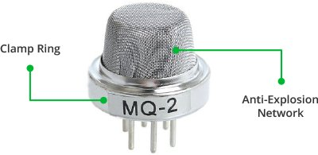

It also provides protection for the sensor and filters out suspended particles so that only gaseous elements are able to pass inside the chamber. The mesh is bound to rest of the body via a copper plated clamping ring.

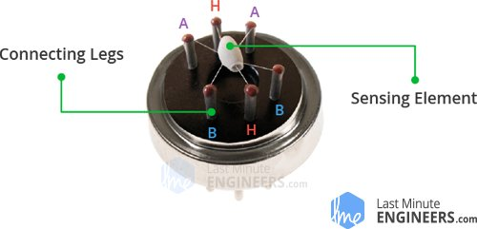

This is how the sensor looks like when outer mesh is removed. The star-shaped structure is formed by the sensing element and six connecting legs that extend beyond the Bakelite base. Out of six, two leads (**H**) are responsible for heating the sensing element and are connected through **Nickel-Chromium coil**, well known conductive alloy.

The remaining four leads (**A** & **B**) responsible for output signals are connected using **Platinum Wires**. These wires are connected to the body of the sensing element and convey small changes in the current that passes through the sensing element.

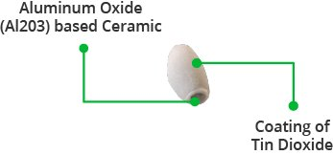

The tubular sensing element is made up of **Aluminum Oxide** (AL2O3) based ceramic and has a coating of **Tin Dioxide** (SnO2). The Tin Dioxide is the most important material being sensitive towards combustible gases. However, the ceramic substrate merely increases heating efficiency and ensures the sensor area is heated to a working temperature constantly.

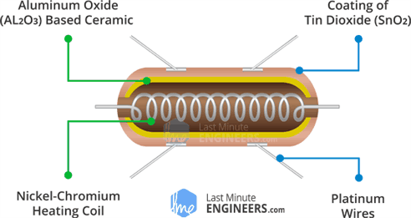

So, the Nickel-Chromium coil and Aluminum Oxide based ceramic forms a **Heating System**; while Platinum wires and coating of Tin Dioxide forms a **Sensing System**.

## **How does a gas sensor work?**

When tin dioxide (semiconductor particles) is heated in air at high temperature, oxygen is adsorbed on the surface. In clean air, donor electrons in tin dioxide are attracted toward oxygen which is adsorbed on the surface of the sensing material. This prevents electric current flow.

In the presence of reducing gases, the surface density of adsorbed oxygen decreases as it reacts with the reducing gases. Electrons are then released into the tin dioxide, allowing current to flow freely through the sensor.

## **Hardware Overview – MQ2 Gas Sensor Module**

Since MQ2 Gas Sensor is not breadboard compatible, we do recommend this handy little breakout board. It’s very easy to use and comes with two different outputs. It not only provides a binary indication of the presence of combustible gases but also an analog representation of their concentration in air.

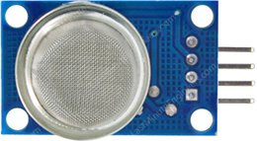

The analog output voltage provided by the sensor changes in proportional to the concentration of smoke/gas. The greater the gas concentration, the higher is the output voltage; while lesser gas concentration results in low output voltage. The following animation illustrates the relationship between gas concentration and output voltage. The analog signal from MQ2 Gas sensor is further fed to LM393 High Precision Comparator (soldered on the bottom of the module), of course to digitize the signal. Along with the comparator is a little potentiometer you can turn to adjust the sensitivity of the sensor. You can use it to adjust the concentration of gas at which the sensor detects it.

## **Calibrate MQ2 Gas Sensor Module**

To calibrate the gas sensor you can hold the gas sensor near smoke/gas you want to detect and keep turning the potentiometer until the Red LED on the module starts glowing. Turn the screw clockwise to increase sensitivity or anticlockwise to decrease sensitivity.

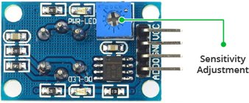

The comparator on the module continuously checks if the analog pin (**A0**) has hit the threshold value set by potentiometer. When it crosses the threshold, the digital pin (**D0**) will go HIGH and signal LED turns on. This setup is very useful when you need to trigger an action when certain threshold is reached. For example, when the smoke crosses a threshold, you can turn on or off a relay or instruct your robot to blow air/sprinkle water. You got the idea!

## **MQ2 Gas Sensor Module Pinout**

Now let’s have a look at the pinout.

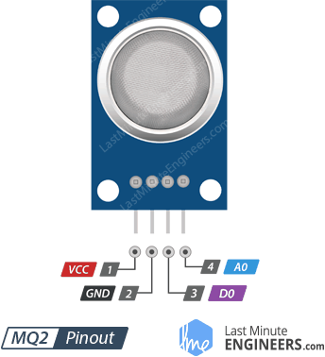

VCC supplies power for the module. You can connect it to 5V output from your Arduino.

GND is the Ground Pin and needs to be connected to GND pin on the Arduino.

D0 provides a digital representation of the presence of combustible gases.

A0 provides analog output voltage in proportional to the concentration of smoke/gas.

# **Carbon Monoxide Sensor(MQ7)**

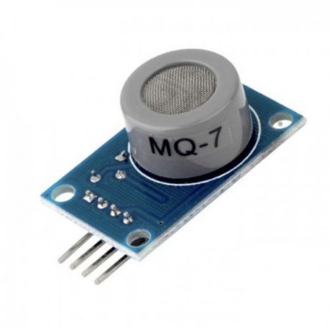

**Description**

MQ-7 Carbon Monoxide Sensor Module detects the concentrations of CO in the air and outputs its reading as an analog voltage. The sensor can measure concentrations of 10 to 10,000 ppm.The sensor can operate at temperatures from -10 to 50°C and consumes less than 150 mA at 5 V.

     This MQ-7 Carbon Monoxide Sensor provides both digital and analog outputs. Threshold level for digital output can be easily adjusted using the preset on the board. MQ-7 sensor module can be easily interfaced with Micro-controllers, arduino and etc.

##### **Electrical properties:**

* Input voltage: DC5V power (current): 150mA
* DO output: TTL digital 0 and 1 (0.1 and 5V)
* AO output :0.1-0 .3 V (relatively clean), the highest concentration of voltage around 4V
* Heater voltage: 5±0.2V（AC•DC)
* Working temperature: -10~50℃ (nominal temperature: 20℃)
* Working humidity: 95%RH (nominal humidity: 65%RH)
* Loading resistance: 10K (adjustable)
* Sensitivity: ≥3% and Response time: ≤1S (preheating 3-5 minutes) and Component power consumption: ≤0.7W and Dimension: 35mm×20mm×11mm

##### **Features:**

* Wide detecting scope
* High sensitivity and fast response
* Long life and stable

1. **433 MHz transmitter module**

The 433MHz wireless module is one of the cheap and easy to use modules for all wireless projects. These modules can be used only in pairs and only simplex communication is possible. Meaning the transmitter can only transmit information and the receiver can only receive it, so you can only send data from point A to B and not from B to A.

The module could cover a minimum of 3 meters and with proper antenna a power supplies it can reach upto 100 meters theoretically. But practically we can hardly get about 30-35 meters in a normal test conditions.

So if you are looking for a simple wireless communication to transmit information within a short distance then these RF pair could be the right choice.

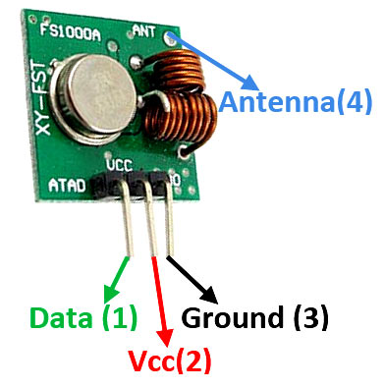

**Pin Configuration:**

|  |  |  |
| --- | --- | --- |
| No: | Pin Name | Description |
| 1 | Vcc | Power supply (+5V only) |
| 2 | Data | Data to be transmitted is sent to this pin |
| 3 | Ground | Connected to the ground of the circuit |
| 4 | Antenna | Solder wire/antenna to improve range (not mandatory) |

**433 MHz Module Specifications:**

* Wireless (RF) Simplex Transmitter and Receiver
* Transmitter Operating Voltage: +5V only
* Transmitter Operating current: 9mA to 40mA
* Operating frequency: 433 MHz
* Transmission Distance: 3 meters (without antenna) to 100 meters (maximum)
* Modulating Technique: ASK (Amplitude shift keying)
* Data Transmission speed: 10Kbps
* Circuit type: Saw resonator
* Low cost and small package

## **433MHz RF receiver**

## **433MHz RF receiver Pinout diagram**

433MHz RF receiver has 6 pins, which offers 4 types of functions. The pinout diagram depicts the functionality of all these pins.

[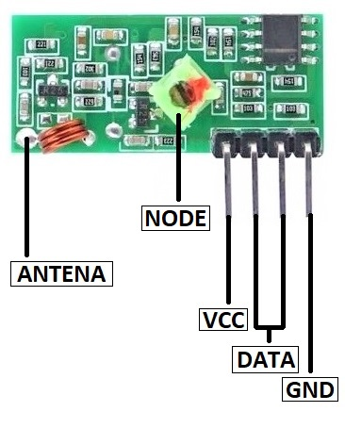](https://microcontrollerslab.com/wp-content/uploads/2020/01/433-MHz-RF-Receiver-Module-Pinout-Configuration-diagram.jpg)

### Pin Configurations Description

**VCC Pin:**VCC is the power input pin for the RF module. The power will active the internal circuit to make it functional.

**GND Pin:**For common ground, the RF module has only one ground pin. The module needs to use with other devices and the common ground will help the RF module to interface with external devices.

**Data Pin:**433MHz RF Module has two data input pins which are internally common with each other. Only data should receive from one pin at a time.

**Antenna Pin:**This module has an antenna pin which helps to connect the external wire to extend the range up to 100 meters. The size of the antenna will depend on the operating frequency.

## **How to use RF receiver**

The RF receiver module may look simple to use but it is a little bit hard to receive the data from itself. The module receives the data in the form of a signal and sends it to the data pin. The data received by the module is always in an encoded form which is decodable by two methods. The first one is through programming and the second is a decoder.

## **433MHz RF Receiver Module Features**

* The RF receiver delivers the output in an encoded form.
* The operating voltage range of the module is 5V maximum.
* The frequency of the receiver is changeable using a green node present on it.
* It is one of the cheapest receivers and has low power consumption.
* 433MHz RF module uses the ASK/OOK signal as an input.

1. **Lcd**

The term [LCD stands for liquid crystal display](https://www.elprocus.com/difference-alphanumeric-display-and-customized-lcd/). It is one kind of electronic display module used in an extensive range of applications like various circuits & devices like mobile phones, calculators, computers, TV sets, etc. These displays are mainly preferred for multi-segment [light-emitting diodes](https://www.elprocus.com/light-emitting-diode-led-working-application/) and seven segments. The main benefits of using this module are inexpensive; simply programmable, animations, and there are no limitations for displaying custom characters, special and even animations, etc.

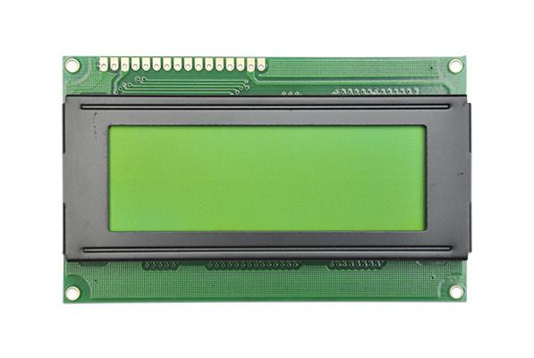

Fig . 20X4 LCD

The 20×4 LCD pinout is shown below.

* Pin1 (Ground/Source Pin): This is a GND pin of display, used to connect the GND terminal of the microcontroller unit or power source.
* Pin2 (VCC/Source Pin): This is the voltage supply pin of the display, used to connect the supply pin of the power source.
* Pin3 (V0/VEE/Control Pin): This pin regulates the difference of the display, used to connect a changeable POT that can supply 0 to 5V.
* Pin4 (Register Select/Control Pin): This pin toggles among command or data register, used to connect a microcontroller unit pin and obtains either 0 or 1(0 = data mode, and 1 = command mode).
* Pin5 (Read/Write/Control Pin): This pin toggles the display among the read or writes operation, and it is connected to a microcontroller unit pin to get either 0 or 1 (0 = Write Operation, and 1 = Read Operation).
* Pin 6 (Enable/Control Pin): This pin should be held high to execute Read/Write process, and it is connected to the microcontroller unit & constantly held high.
* Pins 7-14 (Data Pins): These pins are used to send data to the display. These pins are connected in two-wire modes like 4-wire mode and 8-wire mode. In 4-wire mode, only four pins are connected to the microcontroller unit like 0 to 3, whereas in 8-wire mode, 8-pins are connected to microcontroller unit like 0 to 7.
* Pin15 (+ve pin of the LED): This pin is connected to +5V
* Pin 16 (-ve pin of the LED): This pin is connected to GND.

**Features of LCD16x2**

* The operating voltage of this LCD is 4.7V-5.3V
* It includes two rows where each row can produce 16-characters.
* The utilization of current is 1mA with no backlight
* Every character can be built with a 5×8 pixel box
* The alphanumeric LCDs alphabets & numbers
* Is display can work on two modes like 4-bit & 8-bit
* These are obtainable in Blue & Green Backlight
* It displays a few custom generated characters

**Registers of LCD**

A 16×2 LCD has two [registers](https://www.elprocus.com/know-about-types-of-registers-in-8051-microcontroller/) like data register and command register. The RS (register select) is mainly used to change from one register to another. When the register set is ‘0’, then it is known as command register. Similarly, when the register set is ‘1’, then it is known as data register.

**Command Register**

The main function of the command register is to store the instructions of command which are given to the display. So that predefined tasks can be performed such as clearing the display, initializing, set the cursor place, and display control. Here commands processing can occur within the register.

**Data Register**

The main function of the data register is to store the information which is to be exhibited on the LCD screen. Here, the ASCII value of the character is the information which is to be exhibited on the screen of LCD. Whenever we send the information to LCD, it transmits to the data register, and then the process will be starting there. When register set =1, then the data register will be selected.

**Important command codes for LCD:-**

|  |  |  |
| --- | --- | --- |
| **Sr.**  **No.** | **Hex Code** | **Command to LCD instruction Register** |
| 1 | 01 | Clear display screen |
| 2 | 02 | Return home |
| 3 | 04 | Decrement cursor (shift cursor to left) |
| 4 | 06 | Increment cursor (shift cursor to right) |
| 5 | 05 | Shift display right |
| 6 | 07 | Shift display left |
| 7 | 08 | Display off, cursor off |
| 8 | 0A | Display off, cursor on |
| 9 | 0C | Display on, cursor off |
| 10 | 0E | Display on, cursor blinking |
| 11 | 0F | Display on, cursor blinking |
| 12 | 10 | Shift cursor position to left |
| 13 | 14 | Shift cursor position to right |
| 14 | 18 | Shift the entire display to the left |
| 15 | 1C | Shift the entire display to the right |
| 16 | 80 | Force cursor to beginning ( 1st line) |
| 17 | C0 | Force cursor to beginning ( 2nd line) |
| 18 | 38 | 2 lines and 5×7 matrix |

1. **BUZZER**

Active Buzzer Module KY-012 Arduino module, it produces a single-tone sound when signal is high. To produce different tones use the [KY-006 Passive Buzzer module](https://arduinomodules.info/ky-006-passive-buzzer-module/). The **KY-012 active piezo buzzer** is a 3-pin module that creates an audible sound at 2.5 kHz without the need for pulse width modulation (PWM) or any additional complex code. The only requirement is to set the signal pin to **HIGH**.



**DEVICE PINOUT & SCHEMATICS**

This module has three pins: GND, Vcc+, and Signal.

[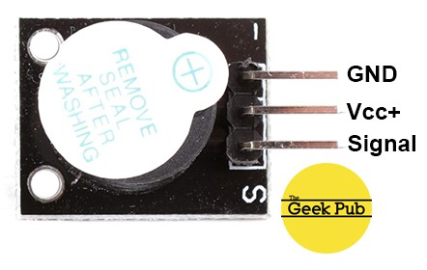](https://cdn.thegeekpub.com/wp-content/uploads/2019/04/KY-012-Active-Piezo-Buzzer-Module-Pinout.jpg)

**KY-012 Specifications**

The KY-012 Active Buzzer module consists of an active piezoelectric buzzer, it generates a sound of aproximately 2.5kHz when signal is high.

|  |  |
| --- | --- |
| Operating Voltage | 3.5V ~ 5.5V |
| Maximum Current | 30mA / 5VDC |
| Resonance Frequency | 2500Hz ± 300Hz |
| Minimum Sound Output | 85Db @ 10cm |
| Working Temperature | -20°C ~ 70°C [-4°F ~ 158°F] |
| Storage Temperature | -30°C ~ 105°C [-22°F ~ 221°F] |
| Dimensions | 18.5mm x 15mm [0.728in x 0.591in] |